R Shiny App

To impute missing values before analysis add in the PSM file name, replicate number and starting channel.

Format of data must have the following columns, any other columns are welcome as well.

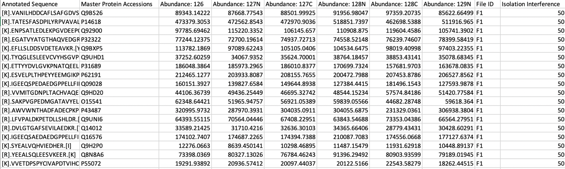

Annotated Sequence, Master Protein Accession, Abundance columns, File ID and Isolation Interference. In the same folder there should be a uniprot .csv file containing just the (first, if there are multiple separated by a semi-colon) Protein Accession numbers and a uniprot gene name .csv file that can be formatted and output from uniport.org containing the same accessions from the uniport .txt file with the second column being the Gene Name.

See example (uni.csv and uni_gn.csv) for details.